PONTE AD H CON 2 RELE’
Controllo verso di rotazione motori in tensione continua.

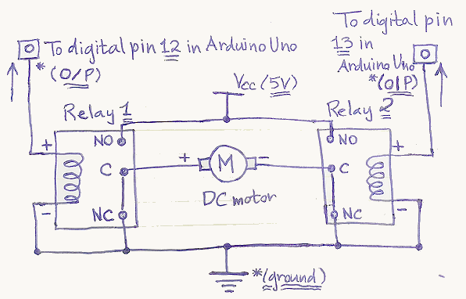

Schema Thinkercad
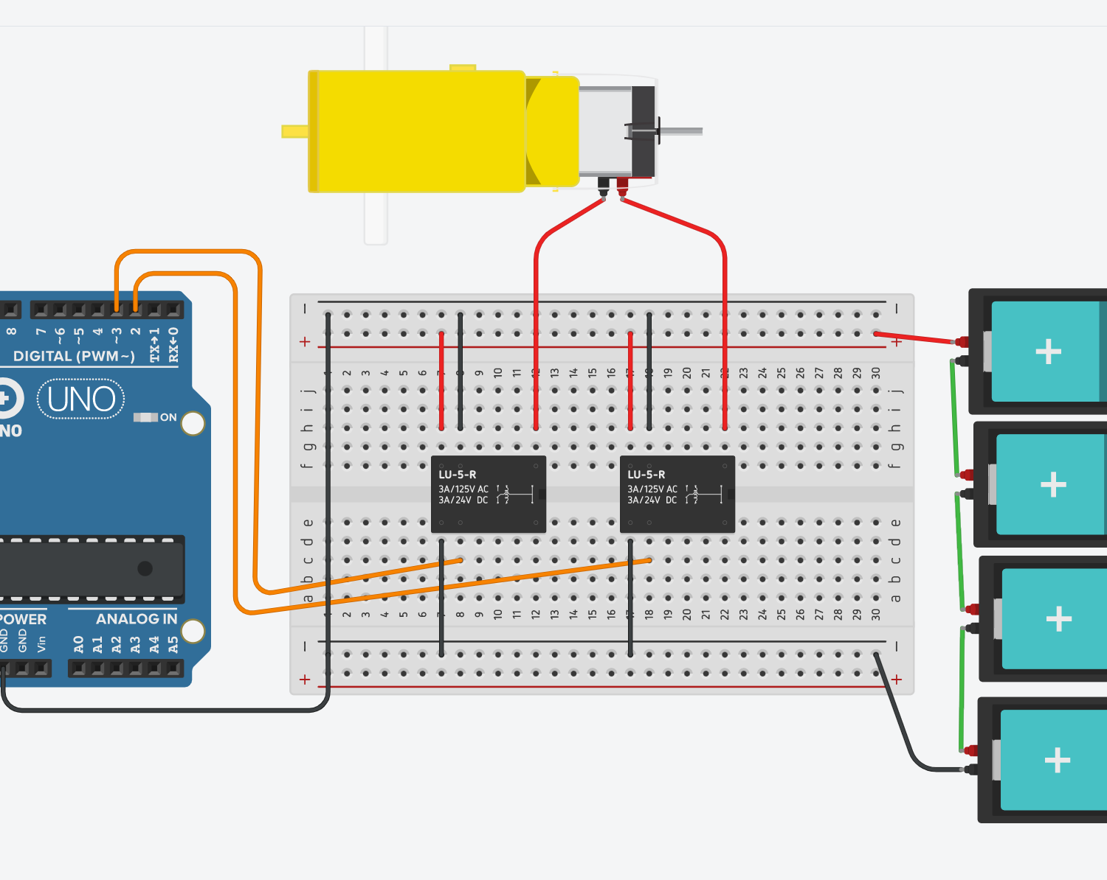

Codice Arduino
int incomingByte = 0; // for incoming serial data

void setup() {
pinMode(2, OUTPUT);
pinMode(3, OUTPUT);
Serial.begin(9600);
}

void loop() {
if (Serial.available() > 0) {
// leggo numeri da 0-9 (1 cifra) associati

incomingByte = Serial.parseInt();
Serial.println(incomingByte);

if (incomingByte==1) {
Serial.println("M1 ORARIO");
digitalWrite(2, HIGH);
digitalWrite(3, LOW);
}
else if (incomingByte==2) {
Serial.println("M1 ANTIORARIO");
digitalWrite(2, LOW);
digitalWrite(3, HIGH);
}
else if (incomingByte==3) {
Serial.println("STOP");
digitalWrite(2, HIGH);
digitalWrite(3, HIGH);
}
else if (incomingByte==4) {
Serial.println("STOP");
digitalWrite(2, LOW);
digitalWrite(3, LOW);
}
else
{
Serial.println("????");
}
}
}

